
Year 8 2020

Mini Test

Statistics and Algebra

Total Marks: 34 marks
Name: ____________________________ Total Time: 34 minutes
Show working and answers on this sheet. Show working in sufficient detail to support your answers. Incorrect answers without supporting reasoning may be allocated zero marks.

Resources Allowed: 1 page A4 notes (1 side), calculator.

Question 1 7 marks

Find the mean, median, mode and range from the Stem and Leaf plot. Show your workings for the mean, median and range in the space provided below. Write your answers in the boxes.

Stem | Leaf
1  2  3 | 2, 6, 7  0, 1, 2, 2  0, 1, 5

Mean
Median
Mode
Range

Question 2 23 marks

Solve the following equations

- $r+4=8$  (1 mark) | - $\frac{y}{7}=5$  (1 mark)
- $2x+7=19$  (2 marks) | - $3a-8=-17$  (2 marks)
- $5\left(2d-4\right)=40$  (3 marks) | - $\frac{4m}{9}-6=-2$  (3 marks)
- $\frac{8+3g}{5}=6$  (3 marks) | - $10-3x=1$  (2 marks)
- $2(5t+4)=3(4+3t)$

(3 marks)
- $37-4m=7-10m$

(3 marks)

Question 3 4 marks

Wendy went to the supermarket to buy milk, soup, pineapple and cereal.
The pineapple cost half as much as the cereal.
The cost of different combinations of her items is shown below.
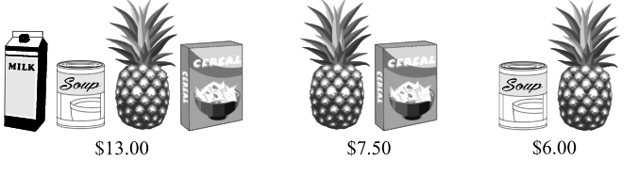
What is the cost of the milk?

